# Introduction

Cumulative impacts of landscape-scale disturbance are threatening ecosystem function of estuaries around the world (CITE). Natural disturbance is inherent to the development and maintenance of estuary ecosystems (CITE), however disturbance caused by humans has led to novel sources, intensities, frequencies, and combinations of press and pulse disturbance (CITE). Examples of anthropogenic press disturbances include land use conversion of estuarine floodplains to impervious cover (Finn et al., 2021), and global impacts of climate change such as altered hydrology or phenological networks (CITE). Ecological consequences of these press disturbances include biodiversity loss or homogenization of species composition (CITE), which are readily exemplified in the literature (CITE, CITE, Lane *et al*., submitted). These ongoing stressors subsequently reduce estuary ecosystem resistance or resilience to intensive pulse disturbances, such as storm surges or overgrazing (CITE). Passive ecological recovery through successional processes is able to proceed with the release of disturbance pressure (CITE). However, biodiversity loss and homogenization from pulse or press stressors may have shifted the compositional abundance of populations available to repopulate the community (CITE), and increases the potential for novel species to become abundant through recruitment into newly available niches (CITE). Competition is one process that drives species dominance within a community (MacArthur, 1958). Post-disturbance changes in community-dominant species composition may be driven by competitive strategies, resulting in successional trajectories alternative to the historical ecosystem context (Muench & Elsey‐Quirk, 2019; Tilman, 2004). A key knowledge gap is understanding how competitive strategies lead to alternative post-disturbance succession in estuaries.

Recovery of estuary vegetation is dependent upon propagules remaining within the disturbed area in the form of seed banks or clonally reproductive individuals at the edges of the disturbed area, or dispersed from outside the disturbed area. In estuaries, clonal vegetative fragments or seeds can be dispersed from within the same estuary (CITE), from the upstream watershed (CITE), or by intertidal dispersal from other estuaries (CITE, CITE, CITE). Each of these dispersal pathways may deliver propagules that are not representative of the historical species composition, creating opportunities for new, estuary-adapted species to competitively dominate the recovering plant community. The ecological memory of historical community composition may be shaped by the historic competitive strategies of the dominant species, and feedbacks between parent plant and seed bank linkages (CITE). Plants may exhibit different competitive advantages through alternative reproductive strategies, such as clonal reproduction or heavy seed production. Tradeoffs exist, however, such as highly competitive clonal reproduction at expense of seed limitation (e.g., *Carex lyngbyei*; CITE). Or, plants may have equally strong clonal and seed reproductive capability, increasing the species’ opportunity for community dominance (e.g., non-native sp.; CITE). Should a species’ competitive strategy (seed or clonal) be removed from the community during a disturbance event, then recovery of that species via succession would be influenced by the relative competitive advantage of remaining propagative material in the disturbed area. The reproductive strategies of a plant community may thus affect an ecosystem’s resilience and whether it returns to a compositional state similar to pre-disturbance conditions (Standish et al., 2014). Anthropogenic legacy impacts such as landscape introduction of non-native species and their respective competitive strategies may derail an historical recovery trajectory, pushing the ecosystem to a novel assemblage (CITE).

Ecosystem consequences of non-native species introductions by humans are well documented (CITE, CITE, CITE). Canada goose (*Branta canadensis*, “CAGO”) was historically an infrequent migrant to the Pacific Northwest of North America, but in the later 20th century, resident populations were introduced to Vancouver Island promote hunting tourism (CITE), and have since become regionally hyperabundant (CITE). In estuaries, CAGO grazing behavior is particularly concerning not only because they heavily graze the leafy above-ground vegetation, but they “grub” or rip out the rhizomes that would be capable of clonally growing to restore the vegetation after grazing (CITE). Subsequent sediment erosion leads to loss of seed banks along with the loss of above- and below-ground vegetation, effectively creating mudflats and resetting succession. Early succession favors ruderal species driven by seed recruitment, resulting in strong similarities in dominant species in the vegetation and the most recent seed inputs to the sediment (surface seed banks) (CITE). In many ecosystems including wetlands and estuaries, dissimilarity of seed banks and parent vegetation increases with greater time since disturbance (Hopfensperger, 2007). Older, climax succession (Clements, 1916) can be exemplified in Pacific Northwest estuaries by the dominance of tall, perennial graminoids (TPGs). These species include rushes, sedges, and grasses with competitive clonal reproductive strategies, although not all species are as strongly competitive by seed production and recruitment (CITE). Restoration efforts employ exclosures to physically prevent CAGO from continuing to graze and grub vegetation (CITE?), with the expectation that successional processes will facilitate passive recovery to an historical compositional abundance in the plant community. However, in an ecosystem experiencing various ongoing disturbance pressures, novel propagule inputs may

The main objective of this study was to understand compositional changes of surface seed banks and above-ground vegetation at discrete stages of recovery since grazing exclusion in two Salish Sea estuaries. We wanted to know if grazing exclusion allows species to passively recover to a compositional abundance similar to undisturbed sites. Traditional succession models would say the most competitive species will increasingly dominate the plant community as time since disturbance increases. This would particularly be the case in a clonal ecosystem, where recovery is driven by species spreading clonally from adjacent undisturbed sites, in addition to potential recruitment from the seed bank. If succession is happening the we expect:

1. Above-ground vegetation at older disturbance sites will be more similar to reference vegetation than recently disturbed (regardless of seed inputs), with respect to compositional abundance of tall, perennial graminoids (TPGs) which dominate this ecosystem.
   1. Alternatively, novel disturbance and novel seed inputs lead to alternative succession pathways, where new competitors from seed inputs derail the "slow encroachment" of the clonal dominant from the neighboring intact site.
2. Above-ground vegetation in recently disturbed sites will be highly similar to seed inputs than older disturbance vegetation similarity to seed, or reference vegetation similarity to seed, especially with respect to compositional abundance of TPGs.

From a conservation and land management perspective, we should be cognizant of long-term grazing impacts on recovery of plant communities and the implications for alternate successional trajectories. This is especially the case in ecosystems such as estuaries, which experience sustained press and intensive pulse disturbances from natural and anthropogenic sources.

# Methods

## Study area & site history

The Little Qualicum River Estuary (LQRE) and Nanaimo River Estuary (NRE) are situated on the east coast of Vancouver Island along the Strait of Georgia (Figure 1), and are unceded territory of the K’omoks, Snuneymuxw, Qualicum, and Nanoose Nations. Prior to European colonial settlement, these estuaries would have been traditionally managed as root gardens to promote the abundance of broadleaf flowering species with starchy roots, rather than the tall, perennial graminoids that dominate the estuaries today (Turner, Lepofsky, & Deur, 2013).

The LQRE was designated as a Wildlife Management Area (WMA) in YYYY, while NRE was designated as a Wildlife Refuge in YYYY. Because these designations confer protection of wildlife habitat, they have been heavily utilized by resident and migratory waterfowl including CAGO (PECP Estuary Ranking, 2021). Observation of intensive grazing in the LQRE led to the establishment of exclosures in 2010 as a trial method to prevent herbivory (DAWE). Local conservation group Guardians of Our Salish Estuaries (formerly Guardians of Mid-Island Estuary Society) continued exclosure construction in both estuaries, opportunistically protecting channel edges where herbivory was most intensive to prevent further loss of habitat (FIG). Exclosures included in this study were selected to represent comparable disturbance conditions at the time of exclosure construction. Despite efforts to protect marsh and channel edge habitat, herbivory is ongoing and areas of habitat degraded by excessive grazing/grubbing remain; grubbed sites selected for comparison were not protected by an exclosure during the study period. Within each estuary, ungrazed habitat is typically found further upstream along tidal channels or interior to the channel edge, and were not protected by exclosures during the study period.

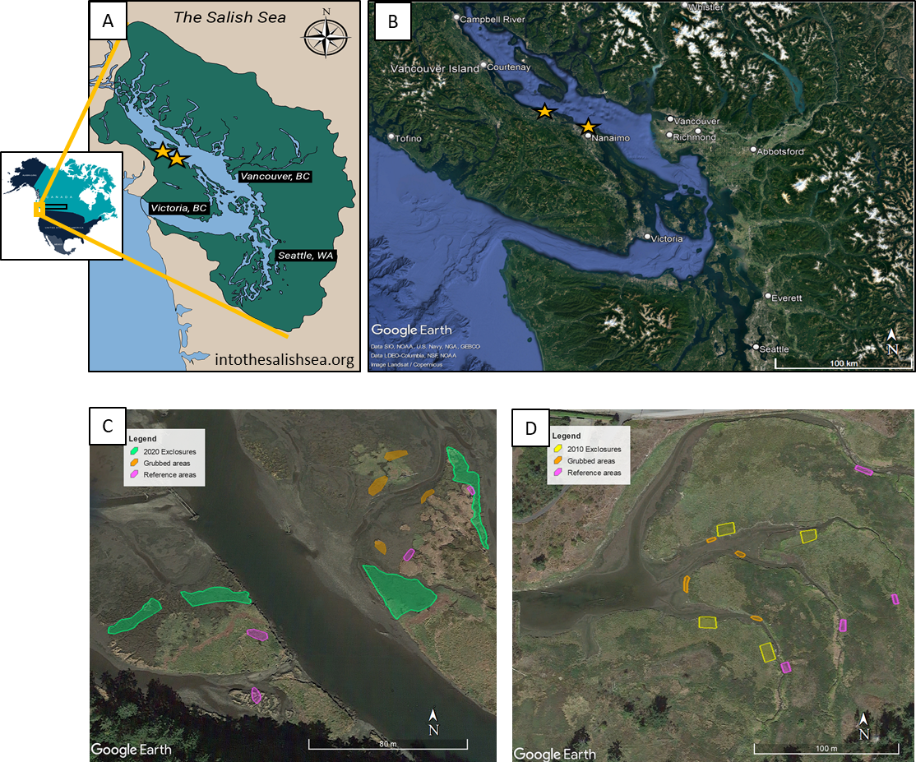

Figure . The Salish Sea spans the US-Canadian border on the Pacific Coast of North America (A). Two estuaries located on the southeastern coast of Vancouver Island (B) were surveyed where grazing disturbance and recovery were observed in the Nanaimo River Estuary (C) and Little Qualicum River Estuary (D).

Table . Grazing disturbance conditions in the Little Qualicum River and Nanaimo Estuaries resulted in conversion of vegetated marsh to partially or fully grubbed mudflats; exclosures were installed to prevent further degradation into the marsh platform. Each estuary sampled n = 4 sites for disturbance category. Two 1 m2 plots were sampled within each site, and two surface seed banks samples were taken from each plot.

|  |  |  |  |  |  |  |  |
| --- | --- | --- | --- | --- | --- | --- | --- |
| **Estuary** | **Time Since Disturbance** | **Disturbance condition** | **Revegetation status** | **Protected by exclosure?** | **Number of sites (exclosures, or comparably sized area)** | **Number of sampling plots per site** | **Number of surface seed bank samples per plot** |
| Little Qualicum, Nanaimo | 0 years (recent grubbing disturbance) | Grubbed | No manipulations | No | 8 | 2 | 2 |
| Nanaimo | 1-year post-grazing/grubbing disturbance | Partially grubbed | No transplants; vegetation recovery from remnant and adjacent vegetation | Yes | 4 | 2 | 2 |
| Little Qualicum | 10 years post-grazing/grubbing disturbance | Partially grubbed | No transplants; vegetation recovery from remnant and adjacent vegetation | Yes | 4 | 2 | 2 |
| Little Qualicum, Nanaimo | No known grazing disturbance | Undisturbed | No manipulations | No | 8 | 2 | 2 |

## Sampling methods

### Vegetation sampling

Vegetation sampling was conducted once in mid-July, 2021. Two 1 m2 vegetation plots were placed within the exclosures (sites, n = 4 per estuary), at least 1 m from the bank edge and any exclosure boundary, and at least 3 m apart within the exclosure. Quadrats were placed so that the plot edge nearest creek was parallel to the bank.

All vascular species were identified according Hitchcock and Cronquist (1973), and currently accepted nomenclature standardized according to the PLANTS Database of the United States Department of Agriculture, Natural Resources Conservation Science [USDA NRCS]. Species were considered in the plot if at least half of their basal stem(s) were inside the quadrat boundary; overhanging vegetation originating from basal stems outside the plot was not considered. Aerial vegetated cover was estimated to the nearest 3 % (1/32 m2). For any species present with less than 3 % cover, species were assigned 2% cover if > 20 individuals were present, 1 % cover if 2-20 individuals were present, and 0.1% cover for single individuals. Bare ground was estimated as the remainder of the plot area not covered by above-ground vegetation. Any plots with > 100% cover were standardized relative to 100%. To characterize plant structure, species were assigned to a height category tall (> 1 m), medium (50-100 cm), or short (< 50 cm) based on their maximum reported height in the Illustrated Flora of British Columbia (Douglas, Meidinger, & Pojar, 1998).

### Surface seed bank sampling & germination

Two surface seed bank samples were taken from each plot (n = 16 per disturbance condition in each estuary) in summer (July 2020), fall (October 2020), and spring (March 2021). A 10 cm diameter handheld bulb planter (e.g., [Husky 9 in. stainless Steel Bulb Planter, Home Depot, USA](https://www.homedepot.com/p/Husky-9-in-Stainless-Steel-Bulb-Planter-GD210314/317436441)) was used to excise sediment 1 cm deep to capture the surface seed bank. Vegetative roots, rhizomes, or other viable rooted material were removed before placing sample in a plastic zipper bag. All surface seed bank samples from the same estuary and disturbance condition were then homogenized in a clean bucket with 100 mL dechlorinated water. Samples were hand-sifted for any remaining root, rhizome, or vegetative material, then homogenized sample was transferred to a clean plastic zipper bag. Summer and fall 2020 samples were stored at 4o C for approx. 12 weeks to simulate overwinter cold stratification to release seed dormancy (CITE); samples collected in the spring of 2021 underwent natural winter conditions and were not subjected to cold stratification.

Germination trials were conducted under greenhouse conditions with 15 hr daylength at ~ 20o C. Seedling pots (9 cm x 13 cm x 5.7 cm (depth), BRAND) were filled with moist, sterile potting media (Sunshine Mix No. 4, Sun Gro Horticulture, Agawam, MA, United States). Pots were placed in solid cache trays and constantly bottom-watered with municipal tap water.

Seed bank samples were sown by pouring 75 mL sediment over the top of each seedling pot (n = 8 per estuary and disturbance condition) while constantly agitating the homogenized seed bank sample. Seeds were allowed to germinate for 5 weeks, at which time all individuals were counted and removed. The seedling trays were observed for any further germination for another 7-10 days, at which time the samples were discarded. Any species that could not be identified were labelled and transplanted into 38 P plug trays (BRAND) with the same growing media and growing conditions until a positive identification could be made. Representative specimens used to confirm seedling identification were pressed and made available as herbaria.

## Analysis

Tall, perennial graminoids (TPGs) were the response variable of interest because they are the dominant species group in high marsh estuarine communities.

We used generalized linear models with a binomial distribution to fit the response of TPG compositional abundance to test whether species compositional abundance differed among disturbance recovery categories in the above-ground and surface seed bank, respectively (package).

We used indicator species analysis (“indicspecies,” R package De Caceres & Jansen, 2016) to determine which species were significantly characterizing the above-ground vegetation and surface seed bank in each disturbance condition. Species significantly driving compositional abundance in each disturbance category were defined by a biserial correlation coefficient (multipatt func = “r.g.”) and permutational analysis (Dufrene & Legendre, 1997).

# Results

We found above-ground cover abundance of the dominant group of tall, perennial graminoids (TPGs) in 10-year old exclosures recovered to comparable cover abundance as found in Undisturbed sites (Figure 2). However, dominant species composition significantly changed in the above-ground vegetation and surface seed bank (Figure 3). In the Little Qualicum River Estuary, above-ground vegetation with >25% relative cover abundance in both Undisturbed and 10-year old exclosures included three species in common (*A. stolonifera, C. lyngbyei, P. anserina*). The Undisturbed sites had a fourth dominant species (*J. balticus*) with >25% relative cover abundance in above ground vegetation, and this species had > 25% relative abundance in the surface seed banks of both Undisturbed and 10-year old exclosures (Figure 3). Both of these disturbance categories also shared >25% abundance of *A. stolonifera* in the surface seed bank.

Reference sites in both estuaries shared *A. stolonifera, C. lyngbyei,* and *J. balticus* as species with >25% cover in the above ground vegetation, but did not share any species in the surface seed bank with the same abundance. Grubbed sites in both estuaries shared two species with >25% relative abundance in above-ground vegetation (*E. parvula, G. maritima*), although only *E. parvula* was as dominant in the surface seed bank between both estuaries.

Above-ground vegetation in the 1-year old exclosures was dominated by *G. maritima, S. canadensis* (which also dominated the Grubbed sites in just the Little Qualicum River Estuary)*,* and *C. lyngbyei*, however the only species with >25% relative abundance was *S. canadensis*; *C. lyngbyei* was nearly absent from the surface seed bank in Grubbed sites in both estuaries, and from the 1-year old exclosures in Nanaimo River Estuary. (Figure 3)

The dominant species accounted for > 25% mean abundance within each vegetation plot or seed bank sample, but it is useful to have disturbance and recovery indicator species between estuaries. Indicator species analysis characterized above-ground vegetation in Undisturbed sites by two native TPGs and one native forb, while 10-year old exclosures were characterized by a single non-native TPG, *Agrostis stolonifera* (Table 2). This non-native species also characterized the surface seed banks of both the 10-year old exclosures and Undisturbed sites. Surface seed bank indicator species in the 10-year old exclosures were two native species, *Juncus balticus* and *Triglochin maritima*. The above-ground vegetation at Reference sites had these same two indicator species, plus *Carex lyngbyei*.

*C. lyngbyei* is an indicator species shared by Reference surface seed banks and above-ground vegetation. However, this is the only indicator species that Reference sites share between their surface seed banks and above-ground vegetation. Surface seed banks and vegetation both included a TPG (*Juncus* sp.). The seed bank differed from vegetation by including an indicator species that also indicated vegetation in Grubbed sites (*Cotula coronopifolia*) (Table 2)

*Generalized linear models showed Grubbed sites had significantly lower TPG above-ground cover than Undisturbed sites (p = 0.02), although this was not statistically significant in 1-year old exclosures at alpha = 0.05 (p = 0.09). We found the surface seed bank composition of TPGs varied by estuary and disturbance (Figure 2). Our generalized linear models showed Nanaimo River Estuary had significantly lower TPG seed abundance overall (p = 0.02), and Grubbed sites have significantly lower TPG seed abundance, regardless of estuary (p = 0.05).*

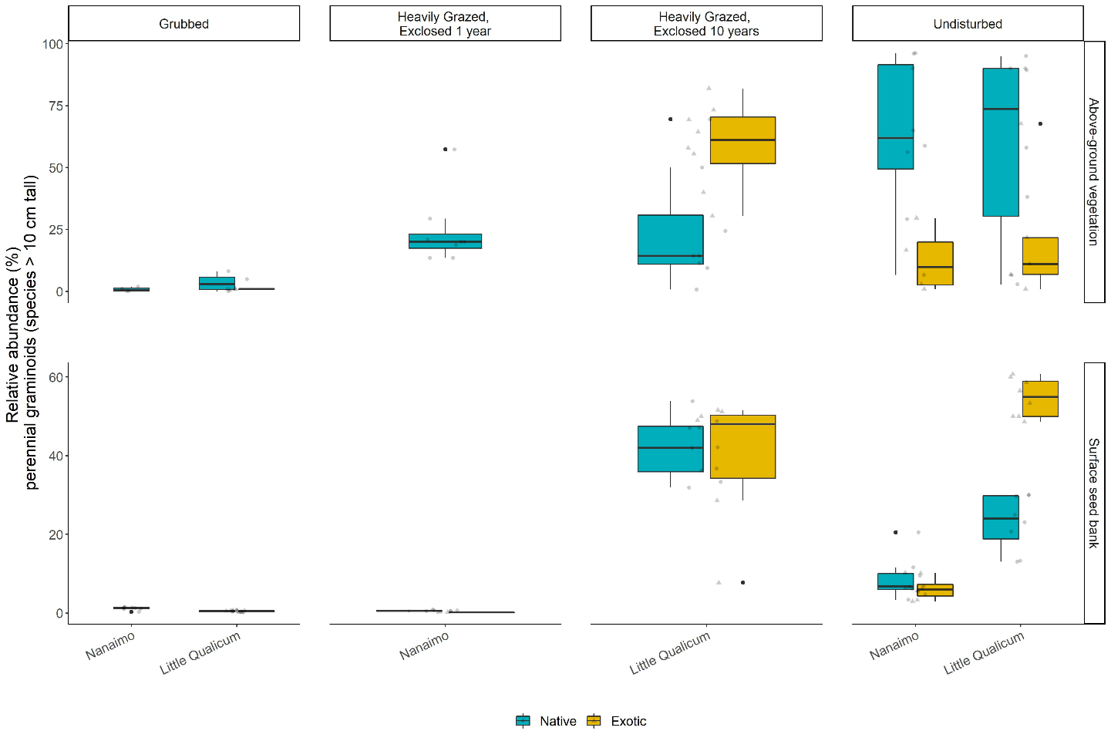

Figure . Above-ground cover abundance of key functional group ‘perennial graminoids (> 10 cm)’ is not significantly different from undisturbed (reference) sites after 10 years. However, indicator species analysis reveals this above-ground cover is dominated by non-native graminoid species Agrostis stolonifera. Moreover, seed bank abundance of tall, perennial graminoids is significantly higher in 10-year old exclosures compared to other disturbance conditions, including undisturbed (reference) sites. Notably, there is nearly equal abundance of non-native and native graminoid seed in 10-year old exclosures, and significantly greater representation of non-native than native graminoid seed in undisturbed sites in Little Qualicum Estuary.

Table . Indicator species analysis identifies which species significantly characterize the above-ground vegetation (left panel) and surface seed bank (right panel) for each disturbance condition, or combination of “recently disturbed” (1-year old exclosures and Grubbed sites) and “recovered” (10-year old exclosures and Undisturbed sites) disturbance conditions. Non-native species are indicated by (*).

|  |  |  |  |  |  |  |
| --- | --- | --- | --- | --- | --- | --- |
| Above Ground Vegetation | | |  | Surface Seed Bank | | |
| **Disturbance** | **Species** | **p-value** |  | **Disturbance** | **Species** | **p-value** |
| Grubbed | *Eleocharis parvula* | < 0.01 |  | Grubbed | *Salicornia depressa* | 0.01 |
| *Cotula coronopifolia\** | 0.04 |  |
| 10-year old exclosures | *Agrostis stolonifera\** | < 0.01 |  | 10-year old exclosures | *Juncus balticus* | < 0.01 |
|  | *Triglochin maritima* | 0.05 |
| Reference | *Juncus balticus* | 0.02 |  | Reference | *Carex lyngbyei* | 0.02 |
| *Carex lyngbyei* | 0.02 |  | *Cotula coronopifolia\** | 0.03 |
| *Triglochin maritima* | 0.04 |  | *Juncus articulatus* | 0.04 |
| 1-year old exclosures + Grubbed | *Spergularia canadensis* | < 0.01 |  | 1-year old exclosures + Grubbed | *Eleocharis parvula* | 0.02 |
| *Glaux maritima* | 0.03 |  | *Spergularia canadensis* | 0.03 |
| 10-year old exclosures + Undisturbed | *Potentilla pacifica* | < 0.01 |  | 10-year old exclosures + Undisturbed | *Agrostis stolonifera\** | < 0.01 |

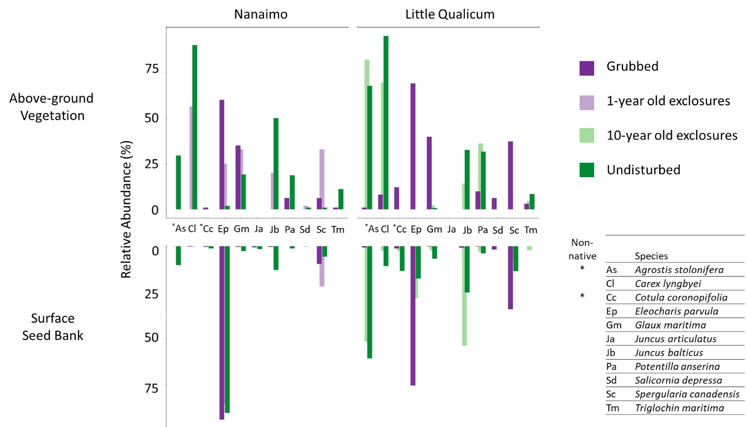

Figure . Relative abundance of species identified by indicator species analysis in above-ground vegetation and surface seed bank at each estuary sampled. Notably, abundance of key native TPGs such as Carex lyngbyei are absent from the seed bank, while others such as Juncus balticus are present in the seed bank but absent in above-ground vegetation, such as observed in 10-year old exclosures at Little Qualicum Estuary.

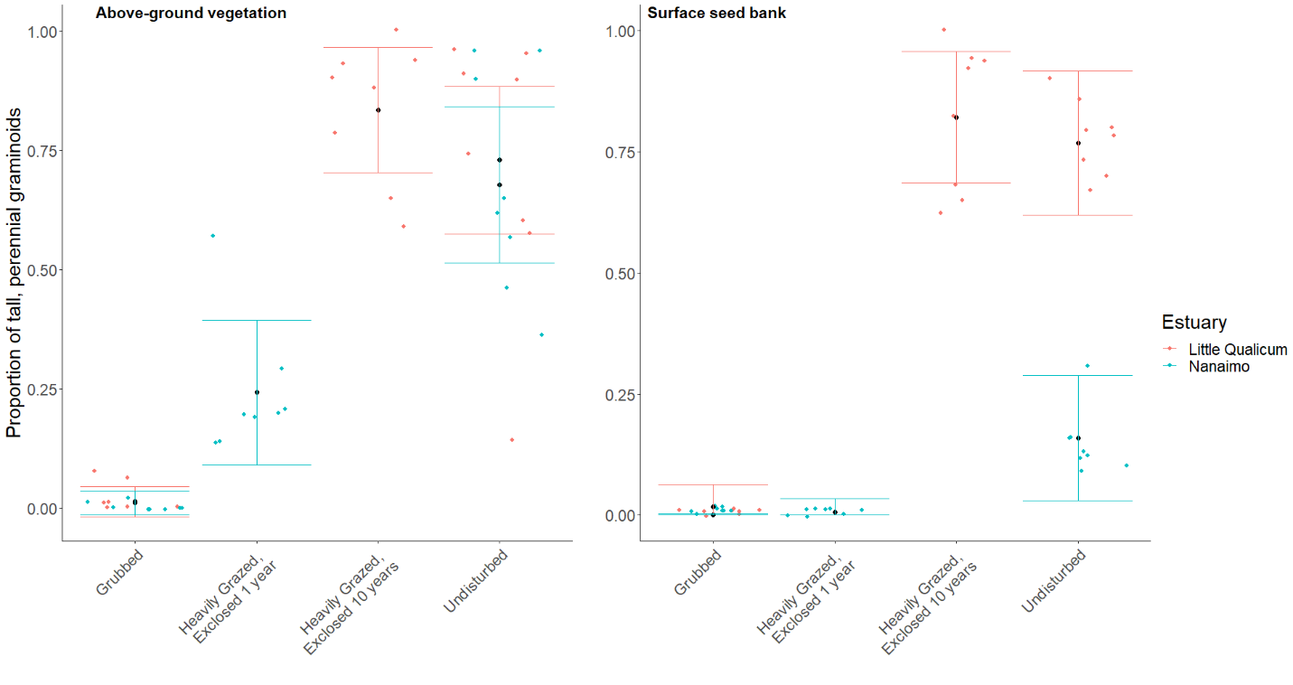

Figure . Actual vs. predicted values for proportion of tall, perennial graminoid in above-ground vegetation cover (left) and surface seed bank samples (right) based on disturbance condition. Actual values plotted as colored points; mean values black points with standard error color coded for each estuary.

# Literature Cited

Clements, F. E. (1916). *Plant succession: An analysis of the development of vegetation*. Washington: Carnegie Institution of Washington.

Douglas, G. W., Meidinger, D., & Pojar, J. (Eds.). (1998). *Illustrated flora of British Columbia. Vols. 1-8*. Victoria, BC: B.C. Min. Environ., Lands and Parks, and B.C. Min. For.

Finn, R. J. R., Chalifour, L., Gergel, S. E., Hinch, S. G., Scott, D. C., & Martin, T. G. (2021). Quantifying lost and inaccessible habitat for Pacific salmon in Canada’s Lower Fraser River. *Ecosphere*, *12*, e03646.

Hitchcock, C. L., & Cronquist, A. (1973). *Flora of the Pacific Northwest, an illustrated manual*. Seattle and London: University of Washington Press.

Hopfensperger, K. N. (2007). A review of similarity between seed bank and standing vegetation across ecosystems. *Oikos*, *116*, 1438–1448.

MacArthur, R. H. (1958). Population Ecology of Some Warblers of Northeastern Coniferous Forests. *Ecology*, *39*, 599–619. JSTOR.

Muench, A., & Elsey‐Quirk, T. (2019). Competitive reversal between plant species is driven by species-specific tolerance to flooding stress and nutrient acquisition during early marsh succession. *Journal of Applied Ecology*, *56*, 2236–2247.

Standish, R. J., Hobbs, R. J., Mayfield, M. M., Bestelmeyer, B. T., Suding, K. N., Battaglia, L. L., … Thomas, P. A. (2014). Resilience in ecology: Abstraction, distraction, or where the action is? *Biological Conservation*, *177*, 43–51.

Tilman, D. (2004). Niche tradeoffs, neutrality, and community structure: A stochastic theory of resource competition, invasion, and community assembly. *Proceedings of the National Academy of Sciences*, *101*, 10854–10861.

Turner, N. J., Lepofsky, D., & Deur, D. (2013). Plant Management Systems of British Columbia’s First Peoples. *BC Studies: The British Columbian Quarterly*, 107–133.

# Supplemental

Table . Placeholder example table for species richness in above-ground vegetation plots (veg) and surface seed bank samples (ssb).

|  |  |  |  |  |
| --- | --- | --- | --- | --- |
| **Total Richness** | **Reference** | **Exclosed 10 yrs** | **Exclosed 1 yr** | **Grubbed** |
| Veg | 5 | 5 | 4 | 5 |
| Ssb | 6 | 7 | 8 | 5 |

Table . Placeholder example table for all species presence in the above-ground vegetation (veg) or surface seed bank (ssb) in each disturbance/recovery category.

|  |  |  |  |  |  |
| --- | --- | --- | --- | --- | --- |
| **Species** | **Group** | **Reference** | **Exclosed 10 yrs** | **Exclosed 1 yr** | **Grubbed** |
| a | TPG | Veg, ssb | Veg | Ssb |  |
| b | Other 1 | Ssb | Veg |  |  |
| c | Other 2 |  | Ssb | Veg | Ssb |
| Etc. |  |  |  |  |  |

Table . Frequency (%) of species found in above-ground vegetation plot replicates for Nanaimo and Little Qualicum River Estuaries, combined, ranked by greatest frequency found in undisturbed plots.

|  |  |  |  |  |
| --- | --- | --- | --- | --- |
| **Species** | **Grubbed** | **Exclosed 1 Year** | **Exclosed 10 years** | **Undisturbed** |
| *Carex lyngbyei* | 31.3 | 100 | 100 | 100 |
| *Potentilla pacifica-anserina* | 31.3 | 0 | 87.5 | 87.5 |
| *Agrostis stolonifera* | 18.8 | 0 | 100 | 56.3 |
| *Glaux maritima* | 75 | 100 | 75 | 56.3 |
| *Juncus balticus* | 0 | 12.5 | 62.5 | 56.3 |
| *Triglochin maritima* | 50 | 12.5 | 37.5 | 43.8 |
| *Deschampsia caespitosa* | 12.5 | 37.5 | 0 | 25 |
| *Atriplex patula* | 0 | 0 | 0 | 18.8 |
| *Eleocharis parvula* | 100 | 75 | 0 | 12.5 |
| *Symphyotrichum subspicatum* | 0 | 0 | 0 | 12.5 |
| *Agropyron repens* | 0 | 0 | 0 | 6.25 |
| *Distichlis spicata* | 12.5 | 25 | 0 | 6.25 |
| *Salicornia depressa* | 62.5 | 25 | 0 | 6.25 |
| *Spergularia canadensis* | 100 | 100 | 0 | 6.25 |
| *Trifolium wormskioldii* | 0 | 0 | 0 | 6.25 |
| *Cotula coronopifolia* | 68.8 | 12.5 | 0 | 0 |

Table . Frequency (%) of species found in seed germination replicates for Nanaimo and Little Qualicum River Estuaries, combined, ranked by greatest frequency found in undisturbed samples.

|  |  |  |  |  |
| --- | --- | --- | --- | --- |
| **Species** | **Grubbed** | **Exclosed 1 Year** | **Exclosed 10 years** | **Undisturbed** |
| *Agrostis stolonifera* | 37.5 | 12.5 | 100 | 100 |
| *Juncus balticus* | 62.5 | 75 | 100 | 100 |
| *Spergularia canadensis* | 100 | 100 | 87.5 | 100 |
| *Eleocharis parvula* | 100 | 100 | 50 | 56.3 |
| *Cotula coronopifolia* | 56.3 | 12.5 | 37.5 | 50 |
| *Carex lyngbyei* | 6.25 | 25 | 25 | 43.8 |
| *Juncus tenuis* | 50 | 87.5 | 0 | 37.5 |
| *Potentilla pacifica-anserina* | 6.3 | 0 | 25 | 31.3 |
| *Glaux maritima* | 43.8 | 12.5 | 37.5 | 25 |
| *Juncus articulatus* | 0 | 0 | 0 | 25 |
| *Symphyotrichum subspicatum* | 6.3 | 0 | 0 | 18.8 |
| *Juncus ensifolius* | 0 | 0 | 0 | 12.5 |
| *Achillea millefolium* | 0 | 0 | 0 | 6.3 |
| *Epilobium ciliatum* | 6.3 | 0 | 0 | 6.3 |
| *Epilobium glaberrimum* | 0 | 0 | 0 | 6.3 |
| *Grindelia sp.* | 0 | 0 | 0 | 6.3 |
| *Isolepis cernua* | 18.8 | 0 | 0 | 6.3 |
| *Triglochin maritima* | 0 | 0 | 25 | 0 |
| *Deschampsia cespitosa* | 0 | 12.5 | 0 | 0 |
| *Distichlis spicata* | 0 | 0 | 0 | 0 |
| *Poa palustris* | 6.3 | 0 | 0 | 0 |
| *Salicornia depressa* | 43.8 | 37.5 | 0 | 0 |

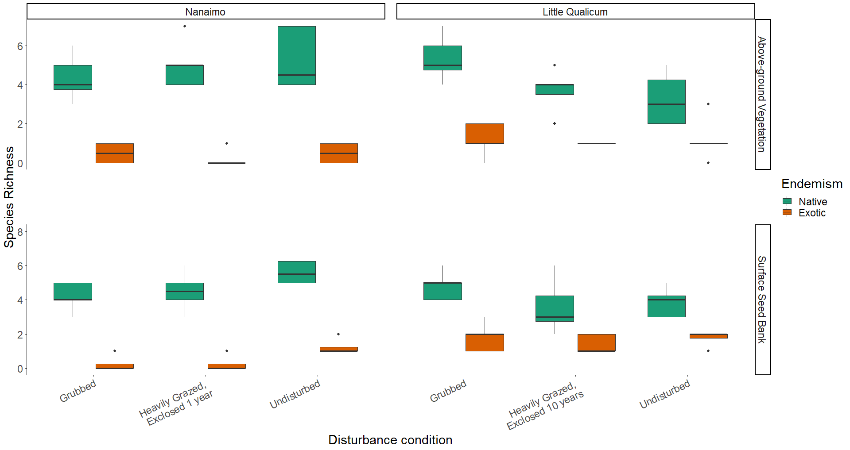

Figure . Native species richness is consistently greater than non-native species richness in both above-ground vegetation and surface seed banks for both estuaries and across all disturbance categories.

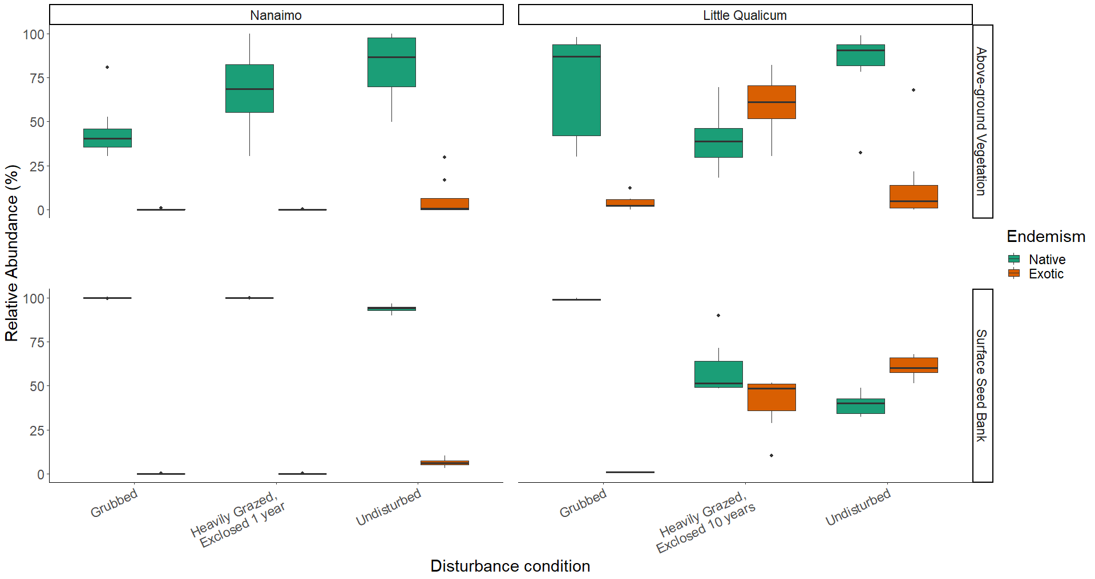

Figure . Above-ground cover abundance of all native species is always significantly greater than all non-native species cover, except in 10-year old exclosures in Little Qualicum River Estuary. Notably, non-native species abundance in the surface seed bank is low across all disturbance conditions in Nanaimo Estuary, but equal to or greater than native species in 10-year old exclosures or undisturbed sites, respectively, in Little Qualicum River Estuary.

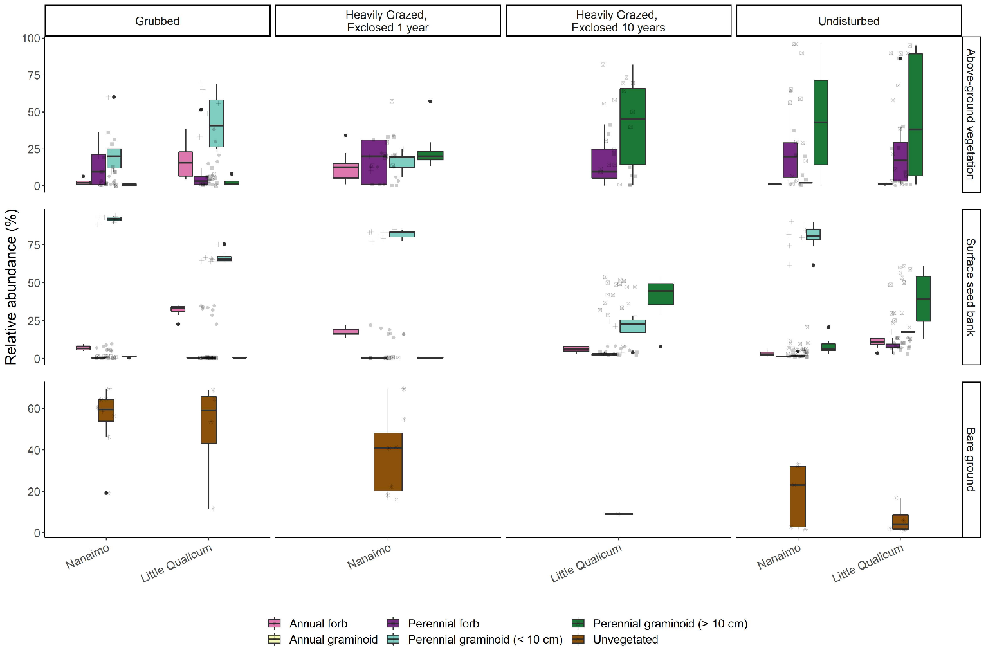

Figure . Recently grubbed and 1-year-old exclosures are dominated by > 50% mean cover of bare ground, with species relative abundance dominated by short perennial graminoid Eleocharis parvula and forbs in both above-ground vegetation and surface seed bank. After 1 year of exclosure, all plant functional groups have similar dominance in above ground vegetation, but surface seed banks do not show increased representation from perennial forbs or perennial graminoids > 10 cm. Bare ground significantly decreases after 10 years of exclosure, while relative abundance of perennial graminoids (> 10 cm) significantly increases in both above-ground vegetation and surface seed banks, not significantly different from undisturbed sites.

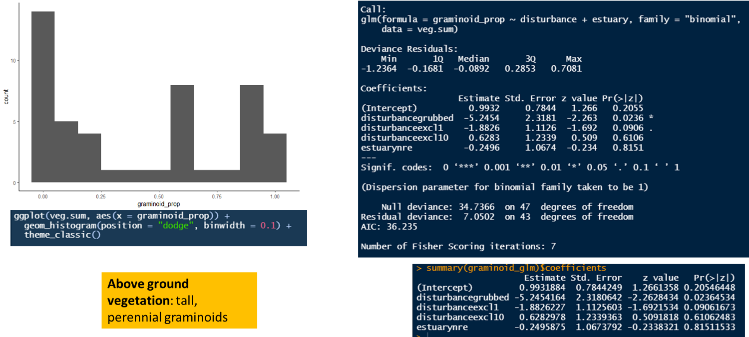

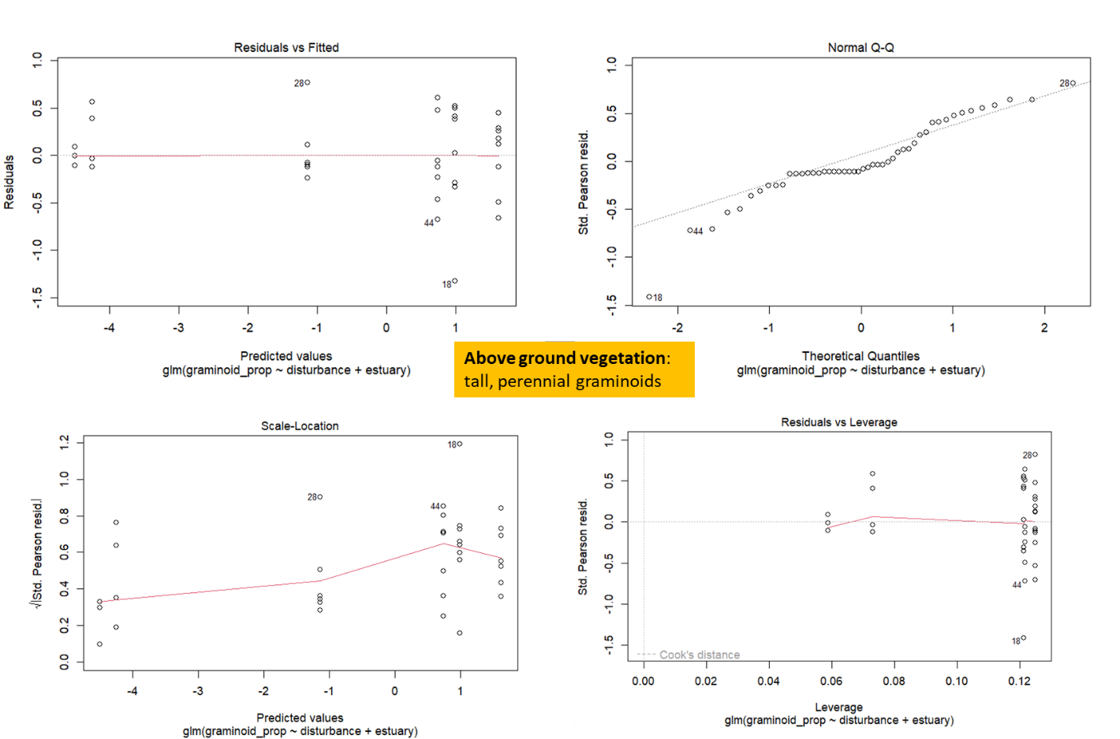

Figure . TEMP FIG - code output for in-text Results reporting glm trends in ABOVE-GROUND VEGETATION. Outliers are individual plots heavily dominated by perennial forbs (especially Douglas aster).

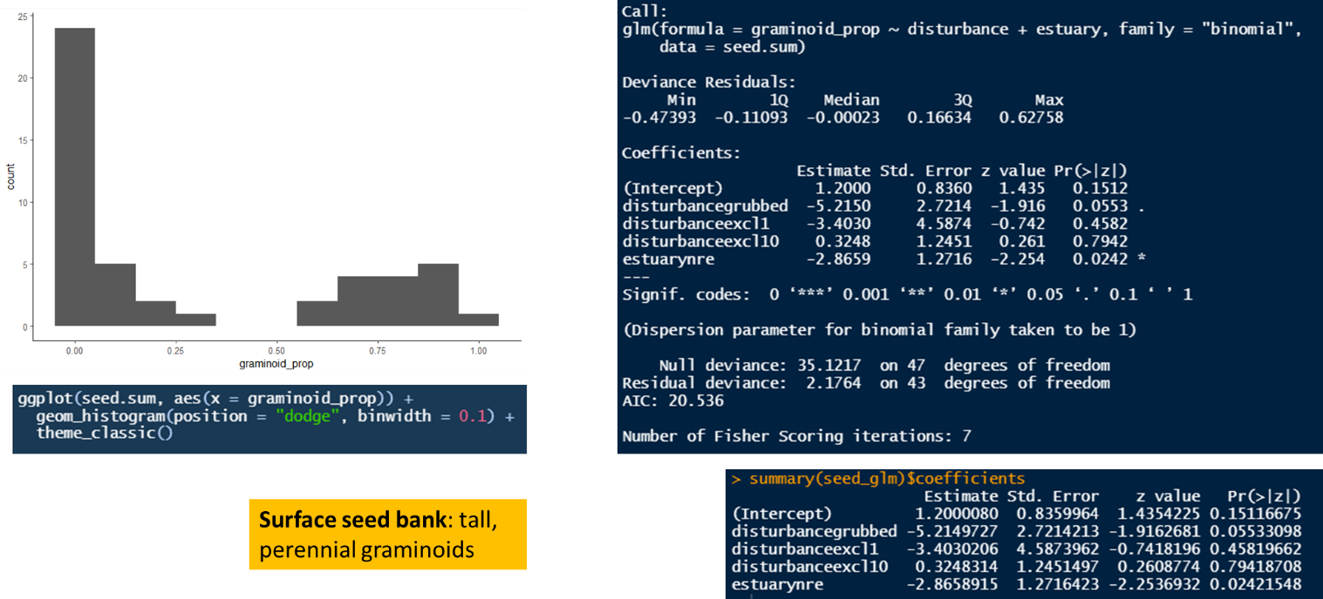

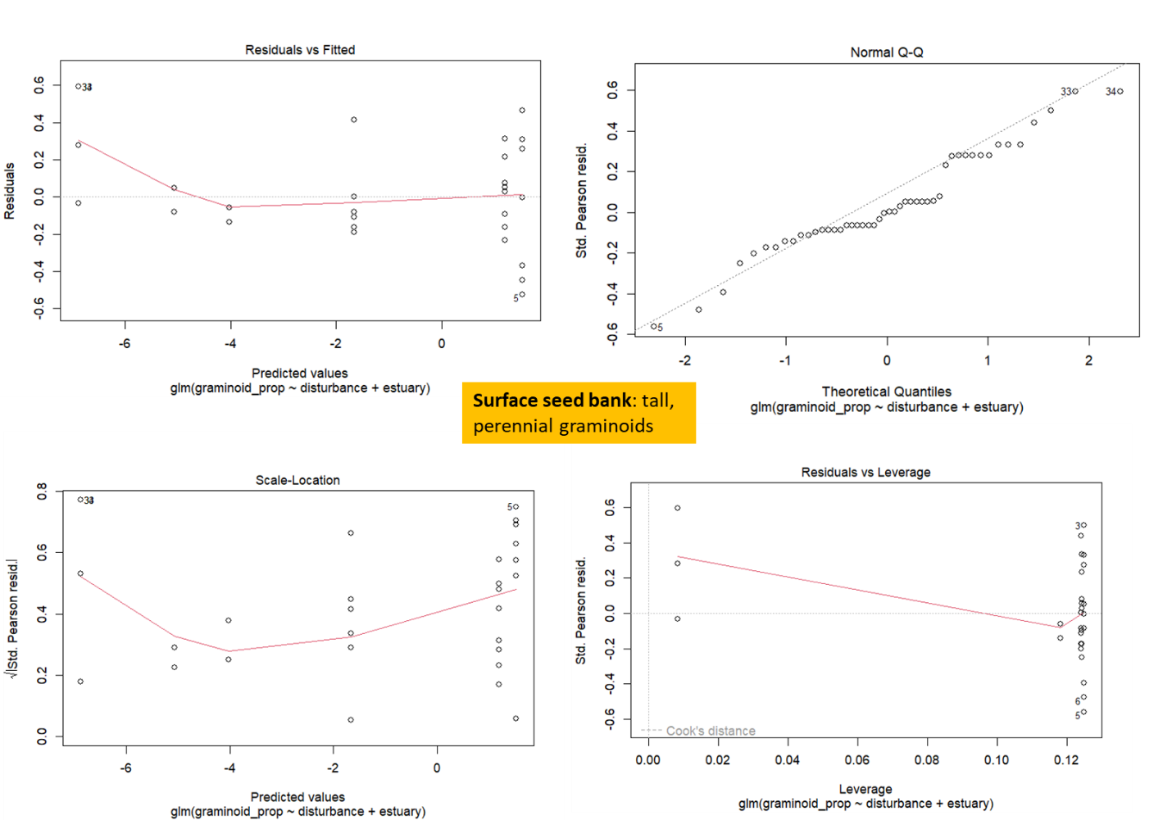

Figure . TEMP FIG - code output for in-text Results reporting glm trends in SURFACE SEED BANK. Outliers are samples dominated by forbs (especially Spergularia canadensis).